* + (Bicanski and burgess 2016) use proximal cues rather than distal - model of retrosplenial cortex - continuous learning of landmark stability - place by direction coding

### 

### 

### **Bilateral, but not unilateral, lesions of the LMNabolishes HD cell activity in the ADN (Tullman and Taube, 1998;Blair and Sharp, 1999)**

**the pathway from DTN → LMNis inhibitory and uses GABA as a neurotransmitter (Gonzalo-Ruizet al., 1993)**

DTN lesions abolish HD signal in ADN (Bassett and Taube, 2001b)

LEsions of other HD areas dont abolish HD firing elsewhere

ThereforeHD singal generated in reciprocal connections between these two regions

anatomical data show no evidence of recurrent excitatory collaterals in the structures of the HD cell system (Boucheny 2005)

### 

### **Knight R, Piette CE, Page H, Walters D, Marozzi E, Nardini M, Stringer S, Jeffery KJ. Weighted cue integration in the rodent head direction system. Philos Trans R Soc Lond B Biol Sci. 2013 Dec 23;369(1635):20120512. doi: 10.1098/rstb.2012.0512.**

HD system relies on landmarks

Combining information from different sensory systems eg vision and vestibular or landmarks and background cues (** important for knowing you are approaching the same place from a different direction)

Two possibilities:

1. Sensory cue integration (average the two cues)
2. Attractor model (winner takes all)

Used a light cue which could be switched between two locations

Most cells PD rotates with cue especially at small cue rotations (+ small undershoot)

Rotations more than 120 degrees lead to larger differences between the cue rotation and PD rotations (more under-rotation) indicating background info becomes more highly prioritised

With more experience of cue conflict the landmark becomes less important. More under rotation with more experience

Weighted cue integration which can be altered (plasticity in feedforward inputs )

Suggest attractor network can work

* Learning about cue reliability

More conflict = learn this is less reliable landmark and integrate with other background cues

Average peak firing rate of the HD cells was 22.98 Hz (How does this compare to my model??)

Questions

* Why under-rotate??? Why does cue not drag the network activity the full rotation? Is this because there is still come conflict? The small undershoot is the averaging the background cue information - with experience of the unreliable landmark the background cues become more important and lead to cmore and more under-rotation

Suggest rapid intertrial reweighting of the landmark onto the ring attractor would result in an intermediate bump

-> strong drive from landmark would lead to movement around the ring before any reweighting can occur

Weak landmarks provide small drive around ring and therefore more time for reweighting?

Pauls paper (goodridge et al ) longer experience of the cue resulted in more rotation ( more confidence in the cue)

High reliability = strong weights onto few HD cells?

** our suggestion of driving the conjunctive layer to more the bump faster of slower depending on error seems novel

This paper talks about landmark input directly onto specific HD cells

Hebbian connections? Eg cell which fires in presence of a specific landmark - this cell is strongly connected to the HDcell which were firing at the time

### Yoder RM, Peck JR, Taube JS. Visual landmark information gains control of the head direction signal at the lateral mammillary nuclei. J Neurosci. 2015 Jan 28;35(4):1354-67. doi: 10.1523/JNEUROSCI.1418-14.2015. PMID: 25632114

Shows visual landmark information controls HD throughout the entire network as HD signal is generated in reciprocal connectiosn between the LMN and

### Arleo A, Déjean C, Allegraud P, Khamassi M, Zugaro MB, Wiener SI. Optic flow stimuli update anterodorsal thalamus head direction neuronal activity in rats. J Neurosci. 2013 Oct 16;33(42):16790-5. doi: 10.1523/JNEUROSCI.2698-13.2013.

optic flow stimulation entrained PDs, albeit at drift speeds slower than the field rotation. This could be due to conflicts with vestibular, motor command, and efferent copy signals

Since the HD cell pathway (containing anterodorsal thalamus) is the only known projection of head direction information to entorhinal grid cells and hippocampal place cells, yaw plane optic flow signals likely influence representations in this spatial reference coordinate system for orientation and navigation.

### **Soman K, Muralidharan V, Chakravarthy VS. A unified hierarchical oscillatory network model of head direction cells, spatially periodic cells, and place cells. Eur J Neurosci. 2018 May;47(10):1266-1281. doi: 10.1111/ejn.13918. Epub 2018 Apr 16. PMID: 29575125.**

### **Weiss S, Derdikman D. Role of the head-direction signal in spatial tasks: when and how does it guide behavior? J Neurophysiol. 2018 Jul 1;120(1):78-87. doi: 10.1152/jn.00560.2017. Epub 2018 Mar 14. PMID: 29537921.**

### **Laurens J, Angelaki DE. A model-based reassessment of the three-dimensional tuning of head direction cells in rats. J Neurophysiol. 2019 Sep 1;122(3):1274-1287. doi: 10.1152/jn.00136.2019. Epub 2019 Jun 26. PMID: 31242041; PMCID: PMC6766745.**

### **Sanguinetti-Scheck JI, Brecht M. Home, head direction stability, and grid cell distortion. J Neurophysiol. 2020 Apr 1;123(4):1392-1406. doi: 10.1152/jn.00518.2019. Epub 2020 Feb 26. PMID: 32101492; PMCID: PMC7191526.**

### **Finkelstein A, Derdikman D, Rubin A, Foerster JN, Las L, Ulanovsky N. Three-dimensional head-direction coding in the bat brain. Nature. 2015 Jan 8;517(7533):159-64. doi: 10.1038/nature14031. Epub 2014 Dec 3. PMID: 25470055.**

### **Kubie JL, Fenton AA. Heading-vector navigation based on head-direction cells and path integration. Hippocampus. 2009 May;19(5):456-79. doi: 10.1002/hipo.20532. PMID: 19072761.**

### **Evans T, Bicanski A, Bush D, Burgess N. How environment and self-motion combine in neural representations of space. J Physiol. 2016 Nov 15;594(22):6535-6546. doi: 10.1113/JP270666. Epub 2016 Jan 6. PMID: 26607203; PMCID: PMC5108893.**

### **Valerio S, Taube JS. Path integration: how the head direction signal maintains and corrects spatial orientation. Nat Neurosci. 2012 Oct;15(10):1445-53. doi: 10.1038/nn.3215. Epub 2012 Sep 16. PMID: 22983210; PMCID: PMC3458173.**

### **Zhu Q, Wang R, Wang Z. A cognitive map model based on spatial and goal-oriented mental exploration in rodents. Behav Brain Res. 2013 Nov 1;256:128-39. doi: 10.1016/j.bbr.2013.05.050. Epub 2013 Jun 5. PMID: 23747608.**

### **Taube JS. Reply to Laurens and Angelaki: A model-based reassessment of the three-dimensional tuning of head direction cells in rats. J Neurophysiol. 2019 Sep 1;122(3):1288-1289. doi: 10.1152/jn.00525.2019. PMID: 31518184.**

### **Dillingham CM, Vann SD. Why Isn't the Head Direction System Necessary for Direction? Lessons From the Lateral Mammillary Nuclei. Front Neural Circuits. 2019 Sep 13;13:60. doi: 10.3389/fncir.2019.00060. PMID: 31619970; PMCID: PMC6759954.**

### **Angelaki DE, Laurens J. The head direction cell network: attractor dynamics, integration within the navigation system, and three-dimensional properties. Curr Opin Neurobiol. 2020 Feb;60:136-144. doi: 10.1016/j.conb.2019.12.002. Epub 2019 Dec 23. PMID: 31877492; PMCID: PMC7002189.**

### **Bassett JP, Wills TJ, Cacucci F. Self-Organized Attractor Dynamics in the Developing Head Direction Circuit. Curr Biol. 2018 Feb 19;28(4):609-615.e3. doi: 10.1016/j.cub.2018.01.010. Epub 2018 Feb 1. PMID: 29398220; PMCID: PMC5835142.**

'geometrical features (corners) can be used to stabilize HD responses during early post-natal development, at a time when access to distal cues is still limited between P12 and P13, coincides with progressive refinement of whisking at these ages'

A striking characteristic of HD cells is that, although their *absolute* preferred firing directions can change (following [disorientation](https://www.sciencedirect.com/topics/neuroscience/disorientation) or manipulations of the environment), the tunings of simultaneously recorded cells retain their *relative* spatial offsets (** fits with the conjunctive HD cell model)

The position of the activity peak is thought to be updated in response to head movement by the activity of upstream angular velocity-responsive cells, which have been described in the rat [midbrain](https://www.sciencedirect.com/topics/agricultural-and-biological-sciences/protocerebrum)

### **Smith AE, Cheek OA, Sweet ELC, Dudchenko PA, Wood ER. Lesions of the head direction cell system impair direction discrimination. Behav Neurosci. 2019 Dec;133(6):602-613. doi: 10.1037/bne0000341. Epub 2019 Oct 3. PMID: 31580093.**

### **Raudies F, Brandon MP, Chapman GW, Hasselmo ME. Head direction is coded more strongly than movement direction in a population of entorhinal neurons. Brain Res. 2015 Sep 24;1621:355-67. doi: 10.1016/j.brainres.2014.10.053. Epub 2014 Nov 1. PMID: 25451111; PMCID: PMC4427560.**

### **Jeffery KJ, Page HJ, Stringer SM. Optimal cue combination and landmark-stability learning in the head direction system. J Physiol. 2016 Nov 15;594(22):6527-6534. doi: 10.1113/JP272945. Epub 2016 Oct 5. PMID: 27479741; PMCID: PMC5108898.**

### **Bicanski A, Burgess N. Environmental Anchoring of Head Direction in a Computational Model of Retrosplenial Cortex. J Neurosci. 2016 Nov 16;36(46):11601-11618. doi: 10.1523/JNEUROSCI.0516-16.2016. PMID: 27852770; PMCID: PMC5125222.**

### **Shinder ME, Taube JS. Three-dimensional tuning of head direction cells in rats. J Neurophysiol. 2019 Jan 1;121(1):4-37. doi: 10.1152/jn.00880.2017. Epub 2018 Oct 31. PMID: 30379631; PMCID: PMC6383655.**

### **Dudchenko PA, Wood ER, Smith A. A new perspective on the head direction cell system and spatial behavior. Neurosci Biobehav Rev. 2019 Oct;105:24-33. doi: 10.1016/j.neubiorev.2019.06.036. Epub 2019 Jul 2. PMID: 31276715. REVIEW**

The head direction signal is believed to originate in connections between the dorsal tegmental nuclei and the lateral mammillary nuclei, and then project to the anterior [thalamus](https://www.sciencedirect.com/topics/neuroscience/thalamus), the postsubiculum, and the medial [entorhinal cortex](https://www.sciencedirect.com/topics/neuroscience/entorhinal-cortex)

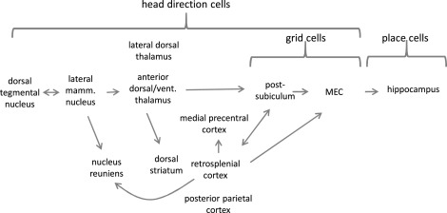

HD cells particularly important for 'homing' and therefore path integration

suggest multiple directional representations

1. on dorsal ventral axis of MEC get sharp turned HD cells in dorsal and wide turned in ventral (Giocomo et al 2014)
2. evidence of different types of HD celll, eg bidirectional (may be driven more strongly by visual inputs)
3. 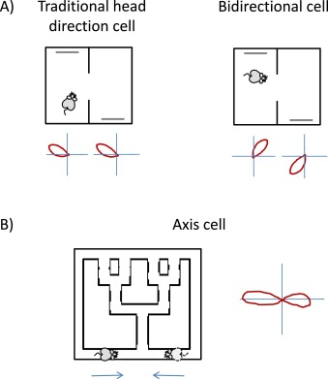
4. at least two functional types of head direction cells in the brain. Presumably, these arise from a different weighting of internal vs. external inputs to specific head direction cells

a) ‘vestibular’ head direction cells - driven primarily by internal dynamics and the [vestibular system](https://www.sciencedirect.com/topics/neuroscience/vestibular-system), and corrected by external landmarks

b) ‘sensory’ head direction cells - driven primarily by external landmarks

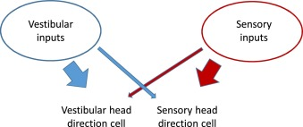

'HD cells can be controlled by visual landmarks, and recent findings from [Yoder et al. (2015)](https://www.sciencedirect.com/science/article/pii/S0149763418309655#bib0575) suggest that this information enters the circuit at the level of the lateral mammillary nucleus'

### **S. Poulter, T. Hartley, C. Lever The neurobiology of mammalian navigation. Curr. Biol., 28 (2018), pp. R1023-R1042 REVIEW**

### **R.M. Grieves, K.J. Jeffery The representation of space in the brain. Behav. Processes, 135 (2017), pp. 113-131 REVIEW**



### **F. Savelli, J.J. Knierim Origin and role of path integration in the cognitive representations of the hippocampus: computational insights into open questions J. Exp. Biol., 222 (2019),** [**10.1242/jeb.188912**](https://doi.org/10.1242/jeb.188912) **REVIEW**

### **Sun X., Mangan M., Yue S. (2018) An Analysis of a Ring Attractor Model for Cue Integration. In: Vouloutsi V. et al. (eds) Biomimetic and Biohybrid Systems. Living Machines 2018. Lecture Notes in Computer Science, vol 10928. Springer, Cham. https://doi.org/10.1007/978-3-319-95972-6_49**

head direction cells combine info about external cues and self motion cues?

Bayes theorem for optimal combination of info from different sources

posterior prob (probability that x will happen when sense a cue) is proportional to the product of

prior poblanos (probability of event x base on prior knowledge)

likelihood function (reliability of cue)

when there are lots of cues is to average cues weighted by their reciprocal variance

ie more reliable cues are heavier weighted

computationally expensive?

they use ring attractor network

kate jeffery group suggested rig attractor with reweighting to do cue integration

these guys show don’t need reweighing

used ring attractor network with single inhibitory interneurone (global)

each excitatory cell has recurrent connections to all the others with connection weights decreasing with distance

give two cues with different headings and different strengths and get integrated activation ( ** this isn’t about head direction is it I’m a bit confusied)

so this is about how estimated heading s from visual cues get averaged into the head direction signal?

weighted average for small conflict and winner takes all for larger ones..

apparently ring attractor network not suitable to model HD system because of physiological constraints… **but the don’t cite or say why…. is it because ever cell is connected to every other cell??? can you not just have more local connections if the weights of the distant connections are so insignificant?

### **Clark BJ, Taube JS. Vestibular and attractor network basis of the head direction cell signal in subcortical circuits. Front Neural Circuits. 2012;6:7. Published 2012 Mar 20. doi:10.3389/fncir.2012.00007**

### **Kim SS, Rouault H, Druckmann S, Jayaraman V. Ring attractor dynamics in the Drosophila central brain. Science. 2017 May 26;356(6340):849-853. doi: 10.1126/science.aal4835. Epub 2017 May 4. PMID: 28473639.**

### **Laurens J, Angelaki DE. A unified internal model theory to resolve the paradox of active versus passive self-motion sensation. Elife. 2017 Oct 18;6:e28074. doi: 10.7554/eLife.28074. PMID: 29043978; PMCID: PMC5839740.**

** relates to conversation with Martin about what happens if head is not facing the direction of actual movement

### **Laurens J, Angelaki DE. The Brain Compass: A Perspective on How Self-Motion Updates the Head Direction Cell Attractor. Neuron. 2018 Jan 17;97(2):275-289. doi: 10.1016/j.neuron.2017.12.020. PMID: 29346751; PMCID: PMC5777220.**

L. Yu, T. Chu, Z. Zhao, Y. Mi, Y. Yang and S. Wu, "Spiking Continuous Attractor Neural Networks with Spike Frequency Adaptation for Anticipative Tracking," 2019 IEEE International Workshop on Future Computing (IWOFC, Hangzhou, China, 2019, pp. 1-3, doi: 10.1109/IWOFC48002.2019.9078445.

<https://ieeexplore.ieee.org/stamp/stamp.jsp?tp=&arnumber=9078445>

G. Tang, A. Shah and K. P. Michmizos, "Spiking Neural Network on Neuromorphic Hardware for Energy-Efficient Unidimensional SLAM," 2019 IEEE/RSJ International Conference on Intelligent Robots and Systems (IROS), Macau, China, 2019, pp. 4176-4181, doi: 10.1109/IROS40897.2019.8967864.

<https://ieeexplore.ieee.org/stamp/stamp.jsp?tp=&arnumber=8967864>

R. Kreiser, M. Cartiglia, J. N. P. Martel, J. Conradt and Y. Sandamirskaya, "A Neuromorphic Approach to Path Integration: A Head-Direction Spiking Neural Network with Vision-driven Reset," 2018 IEEE International Symposium on Circuits and Systems (ISCAS), Florence, 2018, pp. 1-5, doi: 10.1109/ISCAS.2018.8351509.

<https://ieeexplore.ieee.org/stamp/stamp.jsp?tp=&arnumber=8351509>

# [**Michael E. Shinder**](https://journals.physiology.org/doi/full/10.1152/jn.01098.2010#)**, and** [**Jeffrey S. Taube**](https://journals.physiology.org/doi/full/10.1152/jn.01098.2010#)**. Active and passive movement are encoded equally by head direction cells in the anterodorsal thalamus. 2011 Journal of Neurophysiology.** [**https://doi.org/10.1152/jn.01098.2010**](https://doi.org/10.1152/jn.01098.2010)

Developed method to restrain head and body position of rats during recording od HD cells

Found HD responses the same during active and passive movement + not affected by light vs dark

‘maintenance of a stable directional signal without appropriate motor, proprioceptive, or visual input indicates that vestibular input is necessary and sufficient for the generation of the HD signal’

# [**Ryan M. Yode**](http://www.frontiersin.org/people/u/11548)**r and** [**Jeffrey S. Taube**](http://www.frontiersin.org/people/u/19089)**. The vestibular contribution to the head direction signal and navigation. Front. Integr. Neurosci. 2014** [**https://doi.org/10.3389/fnint.2014.00032**](https://doi.org/10.3389/fnint.2014.00032)

head direction (HD) cells dominantly controlled by visual cues, but require input from the vestibular system

external (allothetic) visual cues dominantly control these representations, but self-movement (idiothetic) cues can gain control when familiar visual cues are unavailable

vestibular system includes the semicircular canals and otolith organs, which sense angular and linear acceleration

humans were able to accurately use self-motion cues to accurately update their perceived orientation during active walking or passive transport, but were impaired when they walked in place ([Frissen et al., 2011](https://www.frontiersin.org/articles/10.3389/fnint.2014.00032/full#B36))

In the absence of familiar landmarks, navigation is guided by self-movement cues including motor efference copy, optic flow, proprioception, or vestibular signals

vestibular signals may influence navigation via their involvement with hippocampal theta rhythm

passive rotation induced continuous theta rhythm in rats and mice ([Gavrilov et al., 1995](https://www.frontiersin.org/articles/10.3389/fnint.2014.00032/full#B38); [Shin, 2010](https://www.frontiersin.org/articles/10.3389/fnint.2014.00032/full#B90))

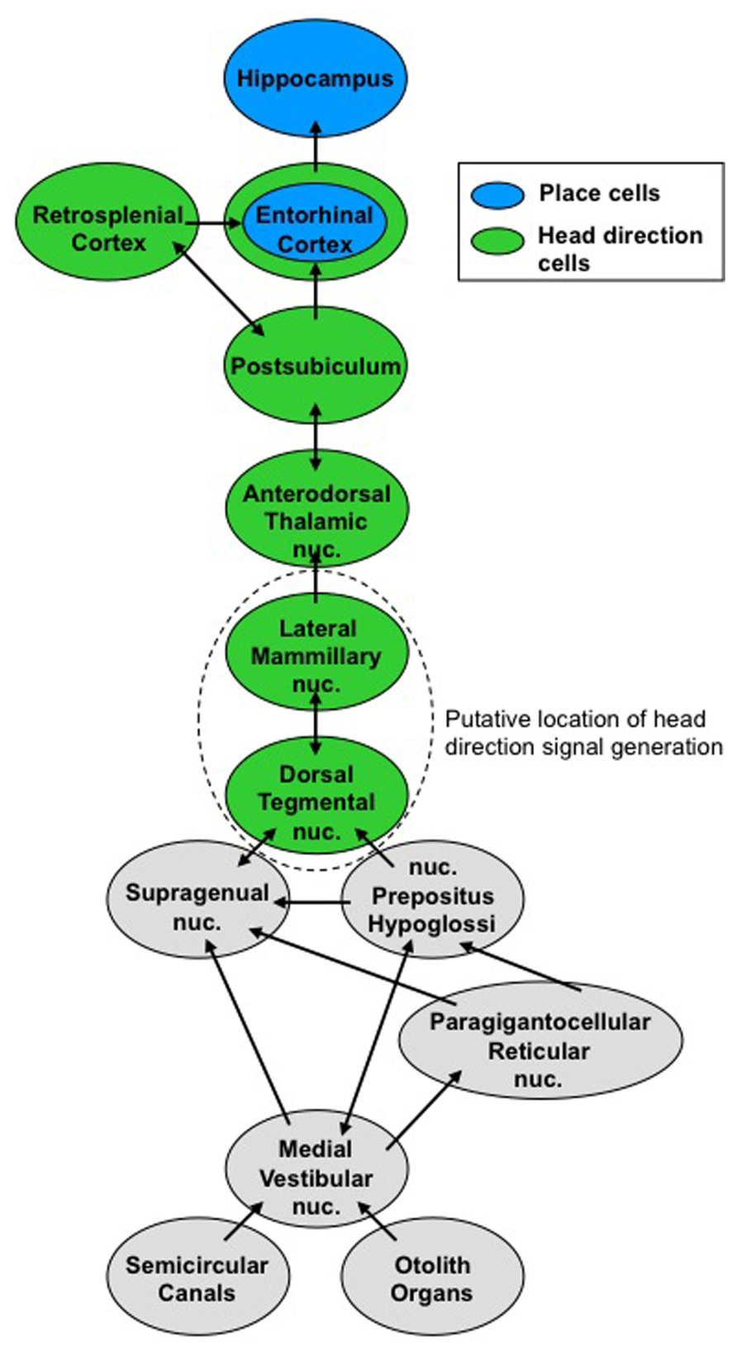

One study evaluated the effects of microgravity on HD cell activity by recording from rats during parabolic flight ([Taube et al., 2004](https://www.frontiersin.org/articles/10.3389/fnint.2014.00032/full#B110)). HD cells remained directional when rats navigated on the floor during 0-*g*, suggesting the otolithic representation of gravity is not crucial for the HD signal. if the animal was passively moved to the walls or ceiling of the apparatus the directional signal was lost - gravity contributes to reorientation when the plane of locomotion changes

# 

# [**M.E.Shinder and J.S.Taube**](https://www.sciencedirect.com/science/article/pii/S0306452214002760?via%3Dihub#!)**. Resolving the active versus passive conundrum for head direction cells. Neuroscience Forefront Review. 2014.** [**https://doi.org/10.1016/j.neuroscience.2014.03.053**](https://doi.org/10.1016/j.neuroscience.2014.03.053)

Talks about mechanisms related to very slow movements where vestibular can’t contribute

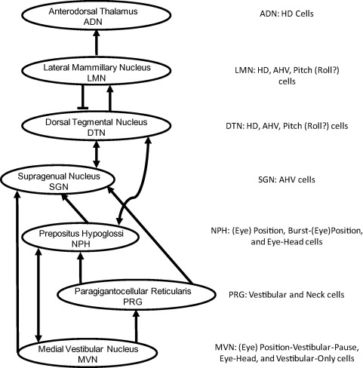

### **Christian Boucheny, Nicolas Brunel, Angelo Arleo A. Continuous Attractor Network Model Without Recurrent Excitation: Maintenance and Integration in the Head Direction Cell System. Journal of Computational Neuroscience 18, 205–227, 2005**

Rather than recurrent excitation to produce ring attractor for HD model they use excitatory and inhibitory populations

3 populations (1 excitatory and 2 inhibitory) - interconnected but no internal connections within a popoul;ation

Angular velocity signals are represented as inputs in one inhibitory population (clockwise turns) or the other (counterclockwise turns).

Although the actual mechanisms underlying the generation of the HD signal are still unclear, anatomical and lesion data suggest that LMN and DTN might constitute an essential sub-circuit of the HD cell system for generating and maintaining the directional signal

They suggest vestibular info into DTN could be modeled as to populations of units which drive the current HD estimate clockwise or counter clockwise respectively

anatomical data show no evidence of recurrent excitatory collaterals in the structures of the HD cell system

Therefore use only connections between the LMN (excitatory) and DTN (left or right inhibitory)

reciprocal connections between LMN and DTN have been demonstrated experimentally

model also assumes that these two DTN networks mutually inhibit each other - shown not necessary but improves performance

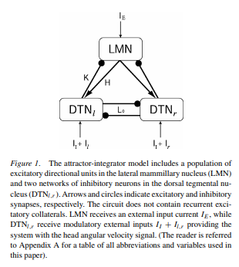

Looks and network stability when vary parameters

All LMN neurons receive an external excitatory input IE inducing a mean background activity of 80 Hz. LMN receives also inhibitory afferents from DTNl and DTNr.

Projection weight depends on difference in preferred direction + an offset (gaussian)

The two populations DTNl,r are also fully interconnected by means of reciprocal inhibitory projections of strength L0 = 0.02.

TOO STRONG INHIBITION LEADS TO CONSTANT VELOCITY MOVEMENT AROUND THE RING (instability!)

One population dominates the other

-> this is similar to the problem i am having

-> try constructing the whole network with much smaller weights?

-> in the examples where the direction it is travelling switches are the closest to a stable set of weights

allothetic sensory inputs (e.g., vision, touch) are necessary to recalibrate pure inertial signals and achieve robust directional coding